SET 2 — Customer Feedback Analysis
According to your experiment sheet, Set 2 uses the Customer Satisfaction dataset and requires a histogram, pie chart, stacked bar chart, and word cloud.
Dataset
Customer ID | Age | Satisfaction Score
1 | 25 | 4
2 | 30 | 5
3 | 35 | 3
4 | 28 | 4
5 | 40 | 5
AIM
To analyze customer satisfaction data using R programming and visualize customer age and satisfaction score distributions using different charts.
ALGORITHM
- Start RStudio.
- Create the customer satisfaction dataset.
- Store Customer ID, Age, and Satisfaction Score.
- Create a histogram to visualize the distribution of customer ages.
- Create a pie chart to show the distribution of satisfaction scores.
- Divide customers into different age groups.
- Create a stacked bar chart to visualize satisfaction scores by age group.
- Create sample open-ended feedback data.
- Generate a word cloud to identify common customer sentiments.
- Add suitable titles and labels.
- Display the results.
- Stop.
R CODE
customer <- data.frame(
ID=c(1,2,3,4,5),
Age=c(25,30,35,28,40),
Satisfaction=c(4,5,3,4,5)
)

# 1. Histogram
hist(customer$Age,
main="Distribution of Customer Ages",
xlab="Age",
ylab="Number of Customers")

# 2. Pie Chart
satisfaction <- table(customer$Satisfaction)

pie(satisfaction,
main="Customer Satisfaction Scores",
labels=paste(names(satisfaction),satisfaction,sep=": "))

# 3. Stacked Bar Chart
customer$AgeGroup <- cut(customer$Age,
breaks=c(20,30,40,50),
labels=c("20-30","31-40","41-50"))

barplot(table(customer$AgeGroup,customer$Satisfaction),
main="Satisfaction by Age Group",
xlab="Satisfaction Score",
ylab="Number of Customers",
legend=TRUE)

# 4. Word Cloud
install.packages("wordcloud",repos="https://cloud.r-project.org")
library(wordcloud)

feedback <- c("good","excellent","average","good","excellent")

wordcloud(feedback,
min.freq=1,
random.order=FALSE)
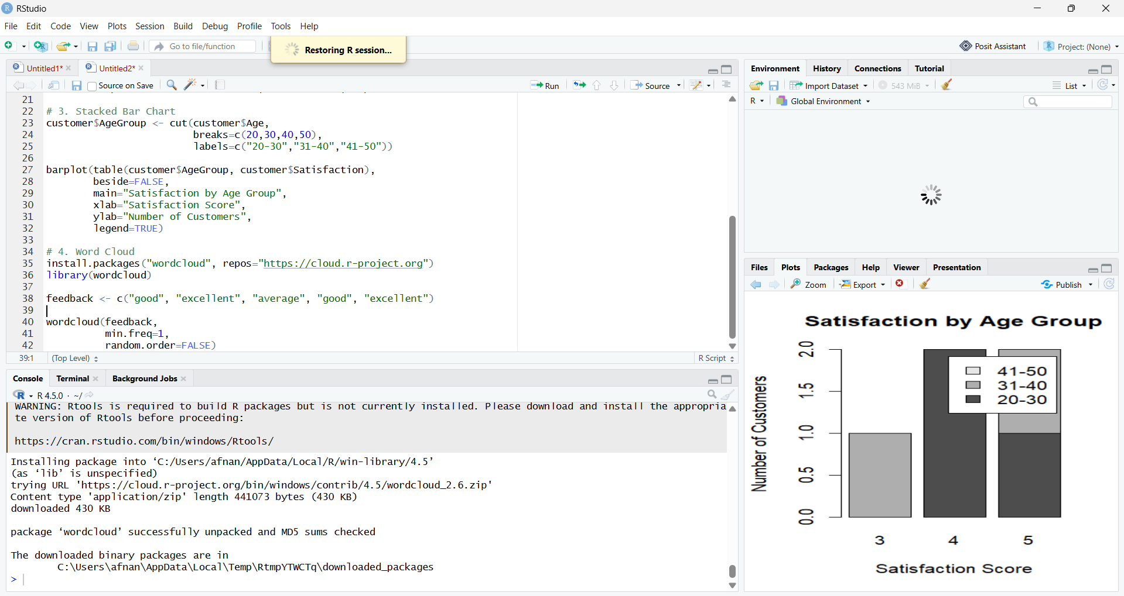
RESULT
Thus, the Customer Feedback Analysis was successfully performed using R programming. The histogram, pie chart, stacked bar chart, and word cloud were created to visualize customer age, satisfaction distribution, satisfaction by age group, and customer sentiments.

